Ex.No:9: PERFORMANCE EVALUATION OF AM GENERATION AND DETECTION UNDER NOISY CHANNEL CONDITIONS USING MATLAB
Objective 1:
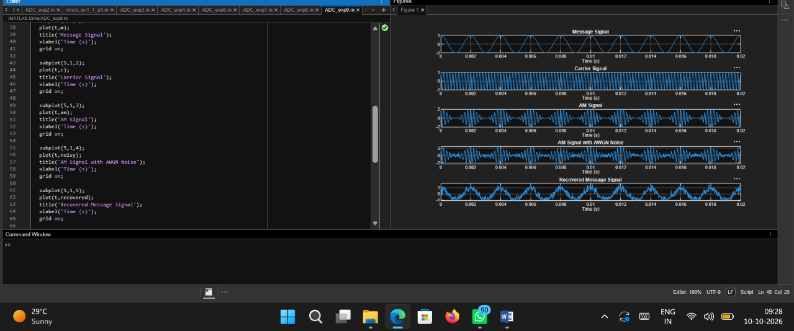
Code:
clc;
clear;
close all;

% Parameters
fs = 100000;
t = 0:1/fs:0.02;
fm = 500;
fc = 5000;

% Message Signal
m = cos(2*pi*fm*t);

% Carrier Signal
c = cos(2*pi*fc*t);

% AM Modulation
am = (1 + m).*c;

% Add AWGN Noise (10 dB SNR)
snr_db = 10;
signal_power = mean(am.^2);
noise_power = signal_power / (10^(snr_db/10));
noise = sqrt(noise_power) * randn(size(am));
noisy = am + noise;

% Envelope Detection
env = abs(hilbert(noisy));

% Recover Message Signal
recovered = env - mean(env);

% Display Results
figure;

subplot(5,1,1);
plot(t,m);
title('Message Signal');
xlabel('Time (s)');
grid on;

subplot(5,1,2);
plot(t,c);
title('Carrier Signal');
xlabel('Time (s)');
grid on;

subplot(5,1,3);
plot(t,am);
title('AM Signal');
xlabel('Time (s)');
grid on;

subplot(5,1,4);
plot(t,noisy);
title('AM Signal with AWGN Noise');
xlabel('Time (s)');
grid on;

subplot(5,1,5);
plot(t,recovered);
title('Recovered Message Signal');
xlabel('Time (s)');
grid on;

Output:
